
HOLY TRINITY COLLEGE
CATHOLIC UNIVERSITY OF ZIMBABWE
149 Enterprise Road, Highlands, Harare
Tel: +263 24 498287 Cell: +263771980999; +263771980888
Email: rector@holytrinity.ac.zw; dean@holytrinity.ac.zw; admin@holytrinity.ac.zw
Web: www.holytrinity.ac.zw

AN ANALYSIS OF TEACHING AS A VOCATION IN THE LIGHT OF LABOREM EXERCENS: A CASE OF KRISTE MAMBO HIGH SCHOOL

SHELTON ZIMONDI, O. CARM. (1806)
SIGNATURE ……………….......................

A Long Paper submitted as a requirement for the completion of a Bachelor of Theology (Honours) Degree

SUPERVISOR:
SIGNATURE: …………………………………..

DECLARATION
I hereby certify that this material, which I now submit for assessment in the program of study leading to the award of the Bachelor of Theology (Honours) Degree is entirely my work and has not been submitted for assessment for any academic purpose other than in partial fulfilment for that stated above.

SIGNED: ………………………………………

CANDIDATE: (1806)

DATE: 01/02/2022

Table of Contents
DECLARATION 1
Table of Contents 2
DEDICATION 4
ACKNOWLEDGMENT 5
ABBREVIATIONS 6
ABSTRACT 7
RESEARCH PROPOSAL 8
Background to the Study 8
Statement of the Problem 9
Purpose of Study 9
Research Questions 10
Objectives of the Study 10
Justification and Significance of the Study 10
Limitations and Delimitations 11
Assumptions 11
Literature Review 12
Methodology 13
Brief outline 14
General Introduction 15
Chapter One 1
1.1. Introduction 1
1.1.1. Brief Background on Human Work 2
1.2. A Synopsis of Rerum Novarum 4
1.3. Work in Laborem Exercens 5
1.4. Other Perspectives of the Church’s Magisterium on Human Work 11
1.5. Conclusion 13
Chapter Two 15
2.1. Introduction 15
2.2. Results and Discussion 16
2.2.1. Teachers’ understanding of their work 16
2.2.2. Teachers’ Motivation for their Work 21
2.2.3. Factors Preventing Teachers Viewing their Work as a Vocation 24
2.2.4. Teachers’ Views on How the Dignity of their Work can be Promoted 26
2.3. Conclusion 27
Chapter Three 29
3.1. Introduction 29
3.2. Inferences of the Study Findings 30
3.3. Proposals 34
3.4. Recommendations for Further Research 38
General Conclusion 39
List of Sources 41
Appendix 1: Questionnaire and Interview Responses 46

DEDICATION
To the late, Tecla Zimondi (nee Chimusoro) and Esther Jongwe (nee Zimondi); and to all people of good will.

ACKNOWLEDGMENT
First and foremost, I would like to express my profound gratitude and praise to God almighty for granting me the energy and strength to accomplish this theological work. I acknowledge Rev. Fr. M. Chikuni, C.Ss.R., for the time he took to guide and supervise my work. I appreciate his generosity and wise counsel. His resolute encouragement from the outset to the conclusion in writing this dissertation is worth mentioning. I also want to convey my profuse gratitude to Br. Blazio Manobo, SPB, Br. Pat Mullins, O. Carm, Br. Theophil Makuni, O. Carm, and Fr. Tryvis Moyo, C.Ss.R., who, due to their proclivity for hard work and dedication, helped me to acknowledge theology, how to value life and appreciate the phenomena around us and be enthusiastic in searching for new knowledge and discoveries. Ultimately, my gratitude to all Holy Trinity lecturers who have provided a platform conducive for my intellectual growth.

ABBREVIATIONS
Col ………………... Colossians
Gen ………………... Genesis
Heb ………………... Hebrews
Jn ………………... John
Lk ………………... Luke
Mt ………………... Matthew
Mk ………………... Mark
LE ………………... Laborem Exercens
RN ………………... Rerum Novarum
St ………………... Saint

ABSTRACT
SHELTON ZIMONDI, O. CARM. (1806)
AN ANALYSIS OF TEACHING AS A VOCATION IN THE LIGHT OF LABOREM EXERCENS: A CASE OF KRISTE MAMBO HIGH SCHOOL
Working can be beneficial and rewarding when seen and understood as a vocation. Sadly, this understanding has been lost in many professions. A good example is the teaching profession. The contemporary teaching work proffered by the secondary school teachers in Zimbabwe seems to be characterised by lack of commitment. Accordingly, challenges such as poor academic performance of students, the increasing rate of repeaters, absenteeism of teachers from work, and teachers asking for a fee for extra-lessons, are attributed to teachers’ lack of commitment. Hence, the prime aim of the research is to study the teachers’ understanding of their work and try to help them, using Laborem Exercens as a means of rediscovering the nobility of their work from the perspective of a vocation. To achieve this aim, the thesis has three objectives: (i) To analyse the Christian understanding of work according to the sacred Tradition and Church’s Magisterium with special focus on the encyclical, Laborem Exercens. (ii) To find out how teachers at Kriste Mambo High School understand their work. (iii) To demonstrate the relationship between work and the vocation of Christian teachers as co-creators. Guided by Laborem Exercens, the scope of the research lies within the framework of studying the Christian understanding of work in order to reconcile it with teachers’ apparent lack of commitment in the work they do. The study will be solely limited to the secondary school teachers at Kriste Mambo High School and to their work in the field of teaching. The methodology is qualitative research, and it will embody library research and interviews using survey questionnaires. The study’s principal conclusion is that, Laborem Exercens’ teaching of work as a vocation remains fundamental to the Christians’ understanding of their work.

Keywords: Work, Vocation, Teacher, Perception, Understanding

RESEARCH PROPOSAL
Area of specialisation: Christian Anthropology

Background to the Study
This writer’s point of departure was drawn from the understanding that “the Church finds in the very first pages of the Book of Genesis the source of her conviction that work is a fundamental dimension of human existence on earth” (Laborem Exercens no. 4). The Church teaches that work constitutes part of the human person’s mission of dominion. As such, human work should be expressed as a vocation. Working can be beneficial and rewarding when seen and understood as a vocation. Sadly, this understanding has been lost in many professions. A good example is the teaching profession. It has been argued that Zimbabwe has recorded several challenges of academic nature among rural secondary schools such as school leadership, career guidance, discipline and dedicated teachers, among others (Nyoni and Garikai 11). According to Ntobeko Ndlovu, the overall student achievement among secondary schools dwindled significantly and this is of great concern (236). The Annual Education Statistics 2019, states that the rate of learners who have to repeat classes is increasing (144). These challenges have been attributed to teachers’ lack of commitment. Cuthbert Majoni asserts that “Current teachers in Zimbabwe are blamed for low quality in the education system” (5). Again, some teachers are charging a fee for extra-lessons. Hence, the introduction of the Statutory Instrument 1 of 2020 banning teachers from conducting extra-lessons in the school without Ministry approval (Muresherwa et al. 342). Teachers seem to have lost pride in doing noble work and are now creative outside their vocation for one reason or another. This writer sought to help these professionals rediscover the nobility of carrying out their work from the perspective of a vocation. To highlight the ‘erosion’ of the concept of a vocation, the study focused on men and women in the secondary school teaching field at Kriste Mambo High School. These teachers were singled out as a case in point that will help highlight the teachers’ understanding of their work. It was this writer’s hope that drawing inspiration from the Scriptures, Magisterial teachings and the psychology of the human person the study was to help teachers rediscover the nobility of their vocation, something that is much needed today than ever.

Statement of the Problem
According to Ntobeko Ndlovu, Zimbabwe’s education system has been under attack for failing to produce good results (236). Likewise, the “current teachers in Zimbabwe are blamed for low quality in the education system” (Majoni 5). Hence, given the challenges such as poor performance of students, the increasing rate of repeaters, absenteeism of teachers from work, and teachers asking for a fee for extra-lessons, the writer was of the idea that these problems were emerging from the teachers’ understanding of their work. The question is: What is the understanding of teachers with regards to their work?

Purpose of Study
The purpose of this study was to help the faithful in the teaching field to understand the vocational nature of their work. The findings of the study were to contribute to the local Church (Archdiocese of Harare) and the Church in Zimbabwe’s pastoral planning.

Research Questions
The study was guided by the following research questions:
- What is the Christian understanding of work according to the sacred Tradition and the Church’s Magisterium – Laborem Exercens?
- How do teachers perceive their work?
- How is work related to the vocation of teachers as co-creators?

Objectives of the Study
Below were the objectives of the study:
- To analyse the Christian understanding of work according to the sacred Tradition and the Church’s Magisterium – Laborem Exercens.
- To find out how teachers understand their work.
- To demonstrate the relationship between work and the vocation of Christian teachers as co-creators.

Justification and Significance of the Study
This study was meant to teach and enlighten teachers who are not aware or who are forced by socio-economic challenges of life to view their work not as a vocation to appreciate and understand it as such. It also intended to help in pastoral planning of the local Church. The study is relevant because it re-emphasised and conscientize the need to understand human work as a vocation. By unpacking how work is a constitutive part of God’s purpose of human beings, the study empowered the faithful to constantly be united with their work and involve God in their daily work. This study was of capital importance because every human being is involved in some work in one way or another. Hence, any Christian who reads this paper would be able to situate one’s work in the study.

Limitations and Delimitations
The study assessed the understanding of secondary school teachers towards their teaching profession and not any other level or profession apart from the teaching field. Given the limitation of time and resources, the study focused on Kriste Mambo High School teachers only hoping that what was discovered with teachers apply to other fields of work. The study employed a purposeful sampling strategy whereby the researcher had to choose nine (9) male and female teachers who have teaching experience ranging from eleven years and above as participants with information necessary for the study. Thematic data analysis was used to gather information which the researcher needed to fulfil the objectives of the study. Since Covid-19 restrictions could not allow physical interactions, the study employed personal interviews through online survey questionnaires in order to facilitate a comprehensive expression of the respondents’ perspectives and the frame of reference within which such perspectives take on personal significance.

Assumptions
The general assumption in this study was that the lack of commitment exuded by teachers in Zimbabwe was due to lack of understanding of their work as a vocation. This writer also assumed that teaching can contribute significantly to learning if teachers were to perceive their work as a vocation rather than only a job or career.

Literature Review
To explore the study at hand, this writer used different books, journals and encyclicals which deal with the Christian understanding of human work. This writer’s point of departure was drawn from the understanding that “the Church finds in the very first pages of the Book of Genesis the source of her conviction that work is a fundamental dimension of human existence on earth” (Laborem Exercens no. 4). In this encyclical, Pope John Paul II discusses the question of work as fundamental to the social question. He also explains how human being’s dominion over the earth is realised through means of work. Although “the Bible in general does not develop a systematic treatment of work as part of the divine plan for humankind, it presents a broad picture that clearly demonstrates how work is a constitutive part of God’s purpose for our race” (A Spirituality of work 3). Thus, the Church deduced the understanding of the human purpose of work from the Bible. Furthermore, the Church teaches that “work is more than a way of earning a living: it is a vocation, a participation in God’s creative activity. The creation of wealth by productive action is blessed by God and praised by the Church, as both a right and a duty” (The Common Good, no. 90). As such, not working is equally against God’s will and that all work should be an expression of a vocation. Hence, as human beings work, they co-create.
In addition, Smit asserts that “we cannot consider the notion of work in the Protestant tradition without first focusing on the notion of calling and vocation” (qtd. in Forster 3). This tallies very well with the Catholic anthropology of work. Thus, the notion of calling is key in theological consideration of work (Forster 6-9). Most importantly, Dion Forster highlights that “in the contemporary worldview, the esteem, status and economic value that we attach to certain tasks and jobs somehow do not reflect God’s values, but rather our own” (Forster 4). Such work alienates the worker from his or her work. Last of all, this writer also appealed to Martin Luther’s assertion that work can be a service or worship. Hence, whatever work a human being does it should give honour to God (4). However, Luther’s theology of work differs from the Catholic one in that it is not deduced from being created in the image of God. For Luther, only Christians are created in the image of God. Accordingly, the above sources are important because they bring variety in the understanding of the Christian anthropology of work.

Methodology
In this dissertation, the writer intended to accomplish the task through reading books and carrying out interviews through questionnaires. A lot has been written on Christian anthropology of work; therefore, the writer considered some of these works by analysing and applying them in the context of Kriste Mambo High School teachers. The study was carried out by using qualitative research methodology and a theological method. A specific attention was given to some of the Church’s Magisterial teachings, particularly, the encyclical: Laborem Exercens (On Human Work). The analysis of the data was done through the re-examination of the specific objectives and the identification of related patterns and connections. A thematic analysis method was employed and the main aim was to ascertain whether or not teachers understand their work as a vocation. Thematic Analysis is a type of qualitative analysis that is used for the analysis, classification and presentation of themes of patterns that relate to the data analysis classifications and present themes (patterns) that relate to the data (Braun & Clarke, 77-101). This was considered the most appropriate for this study so as to allow the researcher to associate an analysis of the frequency of a theme with one of the whole contents for accuracy and the enhancement of a meaningful study. Recommendations and conclusion to the study were given at the end.

Brief outline
  - Introductory material
    - General Introduction
  - Chapter 1: Perspectives on the meaning of work in Laborem Exercens and the Church’s Magisterium
  - Chapter 2: An analysis of teachers’ understanding of work
  - Chapter 3: A demonstration of the relationship between teaching work and the vocation of teachers at Kriste Mambo High School as co-creators
  - General Conclusion

General Introduction
Pope John Paul II’s encyclical, Laborem Exercens, argues that human work must be perceived in the context of its original purpose, its initial value given it by God from the beginning of creation (Naughton and Gene 67). Primarily, the encyclical argues that, by virtue of being God’s image-bearers, human beings are directed to work. In and through work, humanity participates and fulfils God’s will and his creative work. As such, work is a fundamental aspect of human nature ordained by God – it is a vocation. Ultimately, human labour is not meant for economic and psychological functions only, but it should also reflect the ethical and spiritual aspects of the human person. Nonetheless, the contemporary teaching work proffered by the secondary school teachers in Zimbabwe seems to be characterised by lack of commitment. Accordingly, challenges such as poor academic performance of students, the increasing rate of repeaters, absenteeism of teachers from work, and teachers asking for a fee for extra-lessons, are common and these things seem to imply a lack of commitment on the part of teachers. Hence, the principal aim of the research is to study the teachers’ understanding of their work in view of the attributed lack of commitment of teachers in order to help them, using the tool of Laborem Exercens, to rediscover the nobility of their work and vocation. To achieve this aim, the study will focus on the teaching work of the men and women teachers in the secondary school at Kriste Mambo High School. In the first chapter, the researcher analyses the Christian understanding of work according to the Church’s Magisterium; the main focus, however, being the Laborem Exercens. The second chapter presents and analyses the views of the teachers at Kriste Mambo High School on the relationship between their teaching work and vocation. The third chapter demonstrates the relationship between work and the vocation of Christian teachers as co-creators. To conclude, some suggestions, recommendations and areas of further study that might be helpful in understanding work as a vocation will be given.

Chapter One
PERSPECTIVES ON THE MEANING OF WORK IN LABOREM EXERCENS AND THE CHURCH’S MAGISTERIUM

1.1. Introduction
Human beings were created in the image and likeness of God. They are image-bearers of a God who in Genesis is portrayed as a worker. Particularly pertinent, in Genesis, God charges humanity with subduing the earth and having dominion over creation. This divine command was and is still to be fulfilled through work. This directive to work flows from being image-bearers of God. In fact, it is part of being human to work. Put differently, God calls humanity to work, thus, work is a vocation. Accordingly, John Paul II developed in his encyclical, Laborem Exercens, a systematic concept of human dignity in work. He argues from the Scriptures that work is more than just a human activity because it is a fundamental aspect of human nature. For him, work is, as it were, a religious concept. In this chapter, the writer seeks to analyse the Christian understanding of work according to the Church’s Magisterium; the main focus, however, will be given to Laborem Exercens. To achieve this aim, the dissertation will begin in the first section by giving a brief background on human work and on the social teaching in the encyclical, Rerum Novarum which formed the background to the writing of Laborem Exercens. In the second section, the thesis will highlight the perspectives on human work according to Laborem Exercens. In the third section, the writer will present views on human work taught by the Church’s Magisterium. The aspects of discussion include: sanctification of work, work as self-sacrifice and service of others, human work as a call to the cultivation of virtues, work and the common good, and work as evangelisation. Subsequently, a conclusion of the first chapter will be drawn.

1.1.1. Brief Background on Human Work
Thomas Merton writes that human work is intended by God to manifest his love on earth (qtd. in Work Matters 19). Thus, human beings were designed, among other things, for work. Tom Nelson argues further that from the beginning of the Hebrew Bible, God “is not a couch potato God, nor did he create a couch potato world” (20). He is the Creator God – a creative worker. In Genesis 1: 26-28, the writer draws our attention to the uniqueness of humanity in creation. According to Nelson, first, humans are created to exercise proper and responsible dominion over creation. This entails a divinely delegated stewardship role over creation. Second, human beings’ uniqueness is found in the image-bearing of God. Thus, human beings, distinctively, should reflect who God is; his creativity, excellence and glory to the world. Therefore, primarily, our image-bearing reveals God as creator or worker. As Nelson puts it, “God is not some cosmic do-nothing deity” (22). One would ask, why should we work? Definitely, work is fundamental for our sustenance, but is economic gain the foundational reason to work? Certainly, not! Being created in the image of God entails we are designed to work, to be fellow workers, co-creators with God (22). Unequivocally, “we work because we bear the image of the One who works” (22). Subsequently, refusing to work means a critical violation of God’s will for humanity and also, therefore “unnatural”.
In the previous two centuries, there has been a significant development in the Church’s teaching on work. Guided by the Holy Spirit over the years, the bishops, the successors of the apostles, fulfilled their “special duty to Christ to preserve and present revelation, to guide on matters of faith and morals” by developing the Church’s teaching on the place and meaning of work (A Spirituality of Work 10). In accordance with the above, in the nineteenth century, the bishops’ focus was solely on matters of work that appeared to be an affront to human dignity, for instance, issues to do with injustice (10). As a result, the Church’s teachings in that century culminated in Pope Leo XIII’s encyclical, Rerum Novarum (‘new innovations’). Important to note, Rerum Novarum calls us “to save the wretched workers from the brutality of those who make use of human beings as mere instruments for the unstrained acquisition of wealth” (no. 33). Furthermore, in the twentieth century, the Church redirected her focus from issues related to work injustice to grappling with the questions of the nature and role of work itself in God’s plan. The Second Vatican Council fathers in the Pastoral Constitution on the Church in the Modern World (Gaudium et Spes) proclaimed and developed the ecclesial understanding of God’s purpose of human beings as co-workers or associates in the work of creation (A Spirituality of Work 11). By extension, the Council fathers taught that through everyday tasks human beings attain their sustenance and employ their energies for the benefit of society. In their own work is the advancement of the Creator’s work and the benefit of others (Gaudium et Spes, no. 34). This means that the triumph of human work is a clear expression of God’s excellence and the fruit of his divine plan. Over and above the foregoing, building on the foundation of Gaudium et Spes, modern popes, including Paul VI and John Paul II, continued with the Council’s teaching on human work. As such, John Paul II in his encyclical, Laborem Exercens, develops and increases the Church’s understanding of human work, an aspect the thesis is to look at in the third section below.

1.2. A Synopsis of Rerum Novarum
After an expedient thought, in 1892, Pope Leo XIII, wrote an encyclical, Rerum Novarum, addressing the conditions of the working classes. The encyclical deals with matters of rights and mutual duties of both the rich and the poor, of capital and of labour (Rerum Novarum henceforth, RN, no. 2). Leo XIII writes his letter in response to the prevailing rapacious usury such as injustice. The advent of industrialism and capitalism in the nineteenth century resulted in class conflicts. To this effect, “the hiring of labour and the conduct of trade were concentrated in the hands of the comparatively few” (no. 3). Patently, the few in control of industry were increasingly becoming rich from the hard work of the majority – the lower class. In other words, poor working conditions, low wages and animosity of the lower class toward the higher class escalated. Unequivocally, in a bid to correct the unjust social system, Rerum Novarum presents the Catholic Social Teaching on human work. The encyclical reflects on five main issues: private property, the mandate of the Church to speak on social issues, the duty of the state, the right of workers to a just wage and the significance of workers’ unions and organisations (eNotes editorial; RN, no. 43, 48ff). The letter proposes that the Church leaders, who are both chief guardians of religion and dispensers of the Church’s teaching on matters of faith and morals, must once again refute errors that have led to such social evils (RN, no. 16). Nonetheless, it is important to note that Laborem Exercens was written on the ninetieth anniversary of the publication of Rerum Novarum, which addresses the great ‘social question’. Accordingly, in Laborem Exercens, work is at the centre of the ‘social question’ (no. 2).

1.3. Work in Laborem Exercens
The point of departure for John Paul II in his encyclical, Laborem Exercens, is that human work must be perceived in the context of its original purpose, its initial value given it by God from the beginning of creation (Naughton and Gene 67). In the creation narrative, human beings were created in the image and likeness of God to subdue the earth and have dominion over creation (Gen 1:26-28). Specifically, in Laborem Exercens it is argued that because human beings are image-bearers of God, they have a mandate to work which is both a right and a duty (Laborem Exercens henceforth, LE, no. 25; Gaudium et Spes, 341). As John Paul II explains, “at the beginning of human work is the mystery of creation” (no. 12.2). He makes it clear that from the onset human beings are called to work and work is one of the characteristics that distinguish human beings from the rest of creation (LE, no. 1). To elaborate further, work, just like love, prayer and reason, is distinctive to humans. Accordingly, for John Paull II, the social question is a religious question (Naughton and Gene 67). As such, he affirms that the understanding of work does not just refer to its economic and social upshot on society but that it also entails understanding the ‘human’ meaning of work. In essence, Laborem Exercens is largely grounded in the doctrine of creation.
Naughton and Gene assert that, for John Paul II, any proper comprehension of work should be formulated from an anthropology informed by scripture (89). Nevertheless, the encyclical Laborem Exercens posits that even though God’s command in Genesis 1:28 to “subdue the earth” does not refer directly to work, indubitably it indirectly indicates that work is an imperative way for people to subdue creation (Naughton and Gene 74; LE, no. 4.1). According to the encyclical, in fulfilling the mandate given by God to subdue, to dominate, the earth, every human being reflects the very work of the Creator (LE, no. 4). In fact, human beings’ “dominion over the earth is achieved in and by means of work” (no. 5). Therefore, John Paul II understands work as a duty that ultimately arises from God’s command to subdue the earth. Again, the Pope makes it clear that even in the mechanised ‘work’ era, a human being remains the proper subject of work (LE, no. 5). Undeniably, technological instruments facilitate human work, perfecting, accelerating and augmenting it. Nonetheless, all mechanised and technological instruments remain the allies, rather than the masters, of human beings.
Furthermore, Laborem Exercens presents the idea that dominion in a sense refers to the subjective dimension of human work (no. 6). That is to say, human dominion is not only objective but subjective as well. In fact, in Laborem Exercens it is argued that dominion is inclined to the subjective dimension of human work more than to the objective one (no. 6). Even though, however, the subjective aspect takes precedence over the objective one, John Paull II explains that the products and services produced through the work process cannot be divorced from the common good of society which is rooted in the personalistic values of the worker (Naughton and Gene 83). A separation of the product and the producer results in alienation. Hence, the encyclical advocates for full responsibility by the worker not only for the process of work but also of the product/s of work (83). As such, “maximising profits separates stewardship from dominion by producing products only for economic reasons” (85). Put differently, work must not only have an economic or psychological function but also have a fully human meaning. Consequently, this suggests that human work has an ethical value of its own although being vividly, directly and always connected to the human person, one who is a subject that decides about oneself (LE, no. 6).
Moreover, still cognisant of the command to subdue the earth “in which is expressed the will of the Creator that work should enable humans to achieve that “dominion” in the world”, the encyclical teaches us that work is a universal calling for both men and women (LE, no. 9). In the same vein, the basis of this teaching is that God’s fundamental and initial plan for humanity created in the image of God (imago Dei) was never cancelled out or withdrawn even after the Fall of Adam and Eve. In the Fall, the relational part was affected but the dignity remained. As a result, work should never degrade or damage the dignity and subjectivity of human beings. Essentially, the encyclical succinctly points out that work is a good thing for human beings: “a good thing for his or her humanity – because through work human beings not only transform nature, adapting it to their own needs, but they also achieve fulfilment as human beings and indeed, in a sense, become ‘more human being’” (no. 9). Following Thomas Aquinas, John Paul II asserts that “if the practice of virtue makes people more human, then work, practised as industriousness, makes workers more human”. Thus, work is a virtue which corresponds to human dignity and self-esteem, and if people participate in good work, their dignity is affirmed and even increased” (Naughton and Gene 71).
The encyclical Laborem Exercens presents the idea that work constitutes the basis for the stability of family life (LE, no. 10). The encyclical highlights that work makes sustenance for the family possible as well as making possible the achievement of the purposes of family, for example, education. Family, according to Laborem Exercens, is both a community made possible by work and the primary school of work for human beings (no. 10). With regards to the common good, John Paul II teaches that the duty to subdue creation is also the basis of common use of all the world’s goods. Human beings must work, not only for one’s family but also for society and to increase the common good of one’s nation, in which one is an integral member together with compatriots – thus, humans must work for the regard of others (LE, no. 16). Patently, work has a great impact on social organisation. Habiger affirms that the idea of common use is the fact that everyone has a right to have one’s elementary life-sustaining needs satisfied (qtd. in Naughton and Gene 75). Fundamentally, for John Paul II, it is through ownership of the means of production and wages that common use can be realised (LE, no. 14.1-2; 19.1). Grounding the common use further, in John Paul II’s teaching, there is a common destination for all the world’s goods; they are given to all. From this gifting by God arises the right (common) to their usage. Most noteworthy, the encyclical refers to all types of work and not only to manual labour.
Laborem Exercens argues that work is both an obligation and a source of rights for the worker. The encyclical states that our speaking of work as a duty and of the subsequent rights of the worker, should initially draw us to the relationship between the employer and the worker, whether direct or indirect (LE, no. 16). John Paul II affirms that such a relationship is resolved primarily through just remuneration for work done (no. 19). A just wage then becomes the standard measure of verifying the justice of the entire socio-economic system and of checking that it is functioning justly (no. 19). According to the encyclical, a just wage for an adult responsible for a family should be sufficient for proper sustenance of the family and ensuring for its future (no. 19). Ultimately, a just wage is a basic human right. To double-back and reiterate the link between this and the concept of common destination and common use, the right to a just or living wage is based ultimately on the Creator having given us all that is necessary for our daily needs. It is therefore not an invented right, or one conceded to us by a benevolent employer, but intimately related to the right and obligation to work and to receive the products of that work.
Fundamentally, John Paul II sees an important link between human work and the work of God. For him, work has a purpose in the prime design of God’s creative order and to realise this end, human work ought to participate in God’s ongoing work of creation (Naughton and Gene 78). Even though Laborem Exercens never uses the term, the aspect of people being co-creators is ever present in the encyclical (78; LE, no. 13.1; 25). Hence, for human work to be co-creative it must conform to the Creator’s creative order. The cognisance that creation is not a once-off event helps us to have a better understanding of what is meant by co-creation and co-creator. To this effect, Naughton and Gene state that “it is a continuing process, sustained through God’s power and love, in cooperation with people” (78). From Laborem Exercens, we learn that in its subjective sense work is always an actus personae, the act of a person, hence it follows that the whole person, body and spirit take part in it, regardless of the type of work (LE, no. 24). John Paul II reiterates that in and through work, human beings fulfil God’s will. Since human beings are image-bearers of God, by their works in the activity of God, the Creator, and within their own capabilities, they continue the creative activity and perfect it through progressive discovery of the resources and values in the world (no. 25). The very first chapter of the Book of Genesis gives evidence to this truth, “where the creation activity itself is presented as in a form of ‘work’ performed by God during the “six days”” (no. 25; Gen 2:2). For John Paul II, the creation narrative is, as it were, in a sense the first “gospel of work”. It shows what the dignity of work comprises, teaches that humanity ought to imitate God, their Creator in working because of the unique attribute of likeness to God (LE, no. 25). Accordingly, the encyclical maintains that the participation of humanity in God’s continual creative activity is in tandem with God’s command to subdue and have dominion of all creation. Certainly, God’s activity continues in the world through human activity, and such human participation reflects “the very action of the creator” (no. 4.1). Christ’s words give testimony to this fact: “my Father is still working…” (Jn 5:17); he works with creative power by sustaining in existence the world that he called into being from nothing, and he works with salvific power in the hearts of those whom from the beginning he has destined for “rest” in union with himself in his “Father’s house” (Heb 4:1, 9-10; Jn 14:2).
Pursuant to the above, John Paul II also reminds us that the consciousness of human work belongs to a participation in God’s activity and ought to permeate even the most ordinary daily activities (LE, no. 25). Based on this teaching, it is obvious that human successes are a sign of God’s superiority and the thriving of his mysterious design (no. 25). The encyclical states that the aspect of human work as participation in God’s creative work finds its specific prominence in Jesus Christ. It asserts that Jesus did not only proclaim but fulfilled by his deeds the ‘gospel of work’: “Is not this the carpenter?” (Mk. 6:2-3). Thus, “he who proclaimed it was himself a man of work, a carpenter like Joseph of Nazareth” (Mt. 13:55; LE, no. 26). Laborem Exercens argues further that Christ belongs to the “working world” and he appreciates and respects human work (LE, no. 26). A penultimate point is, the encyclical looks at human work in the light of the Cross and the Resurrection of Christ. John Paul II states, therefore that, “the Christian finds in human work a small part of the Cross of Christ and accepts it in the same spirit of redemption in which Christ accepted his Cross for us. In work, thanks to the light that penetrates us from the Resurrection of Christ” (no. 27). Last of all, the Pope exhorts all Christians that inspired by the gospel, uniting work with prayer, they should know that their work has both earthly progress and development of the Kingdom of God (no. 27). Human work is, as it were, a call to establish God’s reign of love, peace and justice on earth – it is a vocation.

1.4. Other Perspectives of the Church’s Magisterium on Human Work
In Populorum Progressio, Pope Paul VI teaches that when God created human beings he endowed them with both intelligence, imagination and sensitivity as well as the means of completing his work in a certain way (no. 27). This suggests that everyone who engages in work co-creates with God. According to Cardinal Basil Hume, while the Church recognises the importance of creation of wealth through human work, she denounces any form of economic power abuses. For instance, those abuses that deprive employees of what is essential for a decent standard of living (Preface, The Common Good). Furthermore, the Catholic Church has always denounced the understanding of employment as merely a form of commercial contract since this alienates the worker from his or her work. Instead, the Church teaches that employment should reflect and affirm the integration of work and worker, and encourage the use of creative skills (The Common Good, no. 91). Essentially, in this sense work enables the worker to become more fully human. Again, the Catholic social teaching holds in great esteem the concept of common good. To emphasise, the Catechism of the Catholic Church teaches that the dignity of the human person requires the pursuit of the common good, which is ‘always oriented toward the progress of persons’ (qtd. in A Spirituality of Work 22). As such, the Catholic bishops of England and Wales, in their document, The Common Good and the Catholic Church’s Social Teaching, describe the common good as a guarantor of individual rights, and the rights of workers are not an exception (22). In fact, work increases the common good.
In the document, The Common Good, the bishops teach that “work is more than a way of earning a living: it is a vocation, a participation in God’s creative activity. The creation of wealth by productive action is blessed by God and praised by the Church, as both a right and a duty” (no. 90). Likewise, if work is properly organised and respects the dignity of the worker, work is a source of fulfilment and satisfaction, the bishops affirm (A Spirituality of Work 22). Subsequently, workers tend to love the work they do. On a similar note, in the teaching of the Second Vatican Council, human work not only alters things and society but develops the worker as well (Gaudium et Spes, no. 35). Moreover, the role of personal work is becoming increasingly critical today as the need to interrelate with the work of others becomes clearer. Fundamentally, work is work with and for others (Centesimus Annus, no. 31). The Church teaches further that whether or not one is actively involved in work, all human beings are presented with an opportunity and an obligation to reflect and act on issues of work and to be cognisant of the results for individuals and societies (A Spirituality of Work 13). Most of all, it is a call for all the baptised Christians who believe that God created human beings in his own image and likeness to know, love and serve him (13). Penultimately, by human competence in secular training, and by human activity, human beings are capable of perfecting created goods by their labour, technical skill and civic culture for the benefit of all people according to the design of the Creator and the light of His Word (Lumen Gentium, no. 36). Thus, humanity is endowed with God the capability to co-create with him and that human work is meant to benefit the whole humanity (A Spirituality of Work 13). According to Gaudium et Spes, it is through human work that we realise and are able to fulfil our vocation to co-create (no. 35).
The Church’s teaching is continuously guided by the Holy Spirit but also by the works of saints. Hence, it is fitting to briefly look at the perspectives of some saints on work. St Ignatius Loyola believed that God, as it were, had a special purpose for every person; a role to work, which only that individual could fulfil (A Spirituality of Work 23). From this saint, the Church realises that each human being is personally called by God to work. St Teresa of Calcutta believed that through all our various works, ‘even journalists’ are called to holiness, and St Therese of Lisieux, espoused a ‘little way’ to holiness – a way of doing the simplest and trivial things with great love (qtd. in A Spirituality of Work 23). Thus, their teachings suggest a capability for everyone to attain salvation through one’s work regardless of the type of work. Another, inspired by the Young Christian Workers, a renowned Catholic, Kevin Flanagan, believes that key features of Christian working life consist of the cultivation of personal qualities coupled with offering work to God (qtd. in A Spirituality of Work 19). To elucidate, Flanagan asserts that in whatever men and women do they, “must turn their office desk, work bench, teacher’s desk into an altar where they offer their work to Christ” (19). This means that human work, among other things, is God-orientated.

1.5. Conclusion
This chapter has shown that in the nineteenth century, the Church focused mainly on issues of work that were affront to human dignity and, in the twentieth century, she redirected her focus on questions of the nature and role of work itself in God’s plan. Hence, a synopsis of the nineteenth century encyclical, Rerum Novarum was presented. In the twentieth century, John Paul II, on the commemoration of the 90th anniversary of Rerum Novarum, building on the teaching of the Second Vatican Council fathers, in his encyclical, Laborem Exercens, developed a systematic teaching on human work. This encyclical argues that human beings as image-bearers of God, were created, among other things for work. The mandate to subdue the earth and to have dominion over all creation is a call to work. Thus, human work is a right and a duty, and it is a virtue which corresponds to human dignity and self-esteem. Again, in and through work, humanity participates and fulfils God’s will and his creative work – they are co-creators. The aspect of dignity of human work and common good are also critical both in Laborem Exercens and the various teachings of the Magisterium of the Church. Work is, but not only, intended for economic or psychological functions, since it is also for evangelisation and establishment of God’s kingdom. Ultimately, John Paul II’s contribution to the understanding of human work remains a milestone in the history of Christian anthropology.

Chapter Two
AN ANALYSIS OF KRISTE MAMBO HIGH SCHOOL TEACHERS’ UNDERSTANDING OF THEIR WORK

2.1. Introduction
In the previous chapter, an attempt was made to discuss the concept of work as a vocation from the perspective of scripture and the magisterium. The chapter observed that the main focus behind the encyclical Laborem Exercens is to show that by virtue of being God’s image-bearers, human beings are directed to work. Thus, in and through work, humanity participates in and fulfils God’s will and his creative work. As such, work is, but not limited to, economic and psychological functions, since it is also for evangelisation and establishment of God’s kingdom. In this chapter, the researcher seeks to present perceptions on the relationship between work and vocation among the teachers at Kriste Mambo High – a school for girls. To achieve this aim, under the heading, results and discussion, the thesis begins by critically looking at teachers’ understanding of their teaching work, followed by what motivates them to teach. Thereafter, it will attempt to ascertain factors preventing teachers from understanding their teaching work as a vocation, and then analyse the teachers’ views on how the dignity of their work can be promoted. Accordingly, a conclusion will be drawn. Data will be obtained through online survey questionnaires and a thematic analysis method employed. The nine (9) participants of the study are Catholic and non-Catholic Christian male and female teachers.

2.2. Results and Discussion

2.2.1. Teachers’ understanding of their work
In a bid to find out the teachers’ understanding of a vocation and how they would describe their own work, the researcher noted from Participant 5 that she understands her vocation as one of helping the girl child and learners in general. Participants 3, 6 and 7 concurred with this view while Participant 7 went further to explain that; “A vocation is a calling to help (serve), and teaching is a vocation where one is called to impart knowledge so as to assist in the growth and development of the community.” Participant 6 affirmed this view as he stated; “My vocation is to help those in need, it is to help people to succeed in life”. From this it can be deduced that teachers understand their work as a calling to serve others. This finding supports the Church’s view that human work should advance the Creator’s work and that it benefits others (Gaudium et Spes 34). Hence, teachers are aware that teaching and their vocation as Christians are intertwined – they are two sides of the same coin. This relationship, “gives an exposure to help the girl child as we interact on a day-to-day basis, inside and outside the classroom environment”, Participant 5 stated. Pursuant of the above, both Participants 3 and 6 see a correlation between the teaching profession and their Christian vocation since, as teachers, they work in loco parentis, helping learners. These discoveries are in harmony with John Paul II’s assertion that there is a connection between human work and the work of God (Naughton and Gene 78). Accordingly, teachers are quite conscious that their work is a call to help, develop and further opportunities for the young ones. Indubitably, the findings suggest that as teachers assist and contribute to the success of the young students, they further God’s work of creation, which is in tandem with God’s instruction to subdue and have dominion of all creation. Therefore, in agreement with Laborem Exercens, the study indicated that teachers’ work reflects, “the very action of the Creator”– they co-create (LE, no. 4.1).
Furthermore, Participant 7 identified the sacrificial element found in teaching with a Christian vocation. He stated that both of them must not be discriminatory. In addition, Participant 8 mentioned that; “The work I do as a teacher and my vocation as a Christian are linked such that in both I do my work for the Lord”. From this, the study shows that some of the teachers understand their work as interwoven with their Christian calling and in both circumstances, they serve the Lord. This finding of the study is in keeping with Laborem Exercens’ assertion that humanity should unite their work and prayer which has both earthly progress and development of the kingdom of God (LE, no. 27). In the same exploration, the researcher discovered that some teachers also view teaching as driven by God’s will and purpose for humanity to grow. Another study by Naughton and Gene also echoes this study’s findings by saying that work has a purpose in the prime design of God’s created order which can be realised through human beings participating in God’s ongoing work of creation (78). To support this, Participant 9 asserted that; “As Christians we were created to be driven by God’s purpose not our own, the same applies to the teaching profession. We are on a mission to teach learners, imparting knowledge to them”. In the same light, Tom Nelson would say, “we work because we bear the image of the One who works” (22). This proves that some teachers understand their teaching work as intended by God and, by fulfilling their calling to teach, they participate in God’s plan for humanity and fulfil their purpose of dominion over and subduing the earth.
Nonetheless, some participants had a different view of a vocation. For Participant 4, “A vocation is a job which earns one a living. It is also a profession attained after one acquires qualification for a job”. Participants 1 and 2 supported this view. It can be deduced that Participants 1, 2 and 4’s understanding of a vocation differs from those alluded to earlier on. For them, it is not God’s call but rather, one that is defined by adequate remuneration which accords with one’s qualifications. A vocation for them is a job or a profession. However, these findings are in some tension with the view of John Paul II who argues that human work must be perceived in the context of its original purpose intended by God (qtd. in Naughton and Gene 67). In other words, a proper comprehension of work should be formulated from anthropology informed by scripture (89). From the research findings, human work is reduced to merely earning a living, that is, solely for financial benefits and perhaps for social status that one is a teacher. Accordingly, such a view would lead one to be alienated from his or her work.
Participant 4 went on to mention that:
My job is far from my vocation as a Christian… I sacrifice to work because the remuneration does not result in any living. I think the relationship between my work as a teacher and my vocation as a Christian is quite compromised because I would end up not practising some of the Christian principles because of demotivation.
The problem of inadequate remuneration cited by Participant 4 does not reflect a lack of understanding of work as a vocation. Instead, it only points towards the justice of work which even the Pope alluded to when he said that a just remuneration for work done by an adult responsible for a family should be sufficient to establish and maintain a family and provide for its future (LE, no. 19). Most noteworthy, the Zimbabwean challenges such as economic meltdown, inadequate remuneration, poor working conditions, poverty, corruption and the government-worker (teacher) engagement, which seems not to provide a clear and equal grounding in work related negotiations, can distort the perception of the significance of their work. Specifically, the present circumstances of economic breakdown subsequently result in unsatisfied physiological and safety needs. To elaborate, the economic meltdown leads to the lack of food, water, shelter, insurance and medical aid, which in turn, make it difficult for teachers to realise the significance of their teaching work. Notably, having unsatisfied basic needs inhibits the attainment of self-actualisation or the realisation of one’s greatest human potentiality (Pfeifer 266). Hence, the justice in teaching work is desideratum.
From the majority of the open-ended questionnaire responses from teachers, the study noted that teachers believe that their work contributes greatly to the less privileged in Zimbabwe. Specifically, by imparting knowledge to learners in the rural areas, mobilising sponsors who would pay for those who cannot afford to pay school fees and influencing learners to form clubs which raise funds to assist the less privileged children, they contribute to the less privileged. However, in contrast to the above, Participants 7 and 9 concurred that their teaching work contributes to the welfare of the less privileged, but to a lesser extent. The former highlighted that; “Recent job action and the issue of a fee for extra-lessons have negatively affected the less privileged who do not have the income to pay for extra-lessons.” In line with this finding, the Church castigates the understanding of employment as merely a form of commercial contract since this alienates the worker from his or her work. Instead, the Church teaches that employment should reflect and affirm the integration of work and worker, and encourage the use of creative skills (The Common Good, no. 91). Affirming the understanding that teaching is a vocation which should intend to serve all learners, Participant 9 stated that; “If we ignore the issue of remuneration and take teaching to be a vocation, then even the less privileged can benefit.” This response affirms Kelvin Flanagan’s argument that, in whatever people do, they “must turn their office, work bench, teacher’s desk into an altar where they offer their work to Christ” (qtd. in A Spirituality of Work 19). These two teachers proved that they know that having extra-lessons outside school where extra charges apart from the school fees are paid, does not conform with their calling to teach and to reach out to all people including the less privileged which Jesus proved to love so much. Accordingly, together with the Church, Participants 7 and 9 castigate the understanding of employment as merely a form of commercial contract. Therefore, from the study in this section, a majority of teachers understood their work as a vocation, with a few recognising a certain tension between their work as a vocation and their work as a source of income.

2.2.2. Teachers’ Motivation for their Work
Under this theme, the researcher sought to explore the teachers’ motivation for their work by examining what enables them to persevere in the teaching field. Likewise, to find out that which teachers like most about their teaching profession. The results show that teachers are motivated to keep on teaching because of their love of children and constant interaction with learners. Furthermore, they are influenced by the promotion of girl child education. The study revealed that teachers understand themselves as agents of change in learners’ lives. As such, the teachers’ love of children supports Nelson’s assertion that, by virtue of being image-bearers of God, human beings, in their work, should distinctively reflect who God is to the world (22). Especially valuable, teachers expressed their passion to witness learners’ growth and development. To elucidate, the responses of Participants 3 and 4 affirmed this fact. The obtained results also demonstrated that teachers are concerned not only with learners’ lives during their school days but similarly by what they become after high school education. This suggests that teachers have great concern for the whole being of learners. To illustrate, Participant 8 finds fulfilment in seeing learners prospering in life after school, a fact seconded by Participant 9 who expressed that;
As a learning mediator, who is in a position to know areas where learners are struggling with and thus helping them through the struggle or those areas where they are strong and thus building on those strengths; it motivates me to see learners being successful in life after school knowing that they passed through my hands.
Certainly, this opinion reveals that teachers are learning mediators who wish to see their learners prosper in life even after school. The findings from this study on teacher motivation supports the views of Nelson who argues that human work is intended by God to manifest his love on earth (19). Again, while Participants 1 and 7 are driven to keep on going in the teaching field by the success of their learners, scoring very good grades, Participant 7 is motivated further by the cognisance that through his work as a teacher, he is immensely helping the nation to grow. Patently, this understanding concurs with the teaching of the Second Vatican Council fathers that human work should benefit all people according to the design of the Creator and the light of His Word (Lumen Gentium no. 36). By extension, human beings are endowed by God with the capability to co-create with him.
However, some of the prominent aspects that teachers like most about their teaching work include the notion of assisting learners to succeed in their academic pursuits and to inculcate good values in them. Importantly, teachers view their work as having a double benefit. That is, it benefits both learners and the teacher. While on the one hand, learners benefit academically, among other things, on the other hand, the teacher, through interaction with learners, keeps on learning new things. Participant 6 showed that work has a great impact on social organisation. He shared that he likes most the fact that through imparting knowledge he contributes positively to the development of the young people which subsequently benefit the growth of the nation at large. Such an expression agrees with John Paul II’s teaching which states that human beings must work, not only for the benefit of their family but also for society and to increase the common good of their nation, in which one is an integral member together with compatriots (LE, no. 16). For example, Participant 9 states that what she likes most about teaching is “The fact that we are there to offer learners experiences, opportunities and life orientations that help them become responsible members of the wider community”. As such, teachers view their work as having regard for others.
Nevertheless, for some teachers, power is what motivates them. To illustrate, the study has discovered that Participant 3 finds joy and contentment in the control and command she exerts on children. Most noteworthy, this seems to be a self-centred driven fondness with less to do with her learners. Moreover, Participant 4 revealed that; “The job is quite flexible, we do have holidays to rest”. On this note, as much as having a holiday and time to rest is vital for every worker, to highlight these as what a teacher likes most concerning her work seems to suggest that one has become a teacher primarily because there is ‘enough’ rest rather than the fundamental aspect of work itself. In this case, teaching may be only for the teacher’s own satisfaction and not for the learners. Such an approach, were it normative, would contrast with the views of John Paul II, who says that people can work for motives outside economic or psychological function (Naughton and Gene 83). Subsequently, this suggests that human work has an ethical value of its own albeit being clearly, directly and always linked to the human person, one who is a subject that decides about oneself (LE, no. 6). The findings above also find support in Maslow’s hierarchy of values which proffers the view that physiological needs are basic but not the ultimate aspirations of human beings (Maslow 35-38).

2.2.3. Factors Preventing Teachers Viewing their Work as a Vocation
This section presents perceptions of teachers on factors that hinders them from viewing their work as a calling. In an effort to find out what causes teachers not to approach their work as a vocation, the study discovered that the socio-economic challenges are the chief factors. Participant 9 supported this view, “Teachers need income to take care of their families in terms of food, fees, medical care, etc.” Likewise, all the nine interviewees mentioned poor remuneration and poor working conditions as the primary factors. In this sense, their experience of working as teachers is not what was envisaged in the teaching of the encyclical, Laborem Exercens, which asserts that work constitutes the basis for the stability of family life (no. 10). Family, as the first community and primary school of work for human beings, is compromised and even deterred from fulfilling its mandate, for example, education (no. 10). Most noteworthy, due to poor remuneration, teachers’ work no longer makes sustenance for the family and its purposes achievable. An analysis of this suggests that the prevailing harsh economic environment in the country is, to a great extent, negatively affecting teachers’ capacity to see their work as a vocation. For that reason, they lose a sense of the nobility of their work all together. Another factor is the existential reality of high unemployment levels, which are leading many to join teaching for survival. Participants 5, 6, 7 and 8 testified to this fact. The findings of the study that others join teaching for merely survival reasons is not in harmony with the Church’s perspective that; “work is” – and should normally be “more than a way of earning a living: it is a vocation” (The Common Good, no. 90).
Participant 2 shared that poverty is one of the factors affecting teachers’ understanding of their work as a vocation. As such, the study saw a connection between the experience of Participant 2 and 6 with the latter attesting that; “the social debt, that is, the general background of poverty” is one of the preventive factors. Therefore, Participant 2 recommends an increase of remuneration, among other things. Unequivocally, the lack of a just wage discovered from the study shows that there is injustice happening. For that reason, it suggests that the relationship between the employer and the workers is compromised. Essentially, according to John Paul II, such a relationship is resolved primarily through just remuneration for work done – a just wage is a basic right (LE, no. 19). Lastly, the discovery was made that the teachers do not have enough knowledge about their work as a vocation. To this effect, Participant 6 stated that there is a, “general lack of knowledge on how vital teaching is either by the teacher or other stakeholders.” As recommendations, Participants 3 and 7 indicated that there is a need for service training and workshops on understanding teaching as a vocation. Thus, teachers’ staff development is fundamental. The latter recommends further that such an aspect should be made part of the teachers’ training course. Furthermore, Participant 8 believes that; “Teachers can understand their work better if they are aware of the link between teaching and religion.” This shows that teachers have little knowledge about their work as God’s calling which prompts for the need to educate teachers to be aware of this fundamental aspect of their teaching work. Therefore, the study showed that due to inadequate remuneration and poor working conditions, among other factors, the dignity of teachers and their work are compromised. Using Maslow’s hierarchy of values cited above, the perception that the economic situation of the country militates against the view of work as redemptive, supports the theory’s tenets that higher order needs like self-esteem, and self-actualization cannot be achieved before basic needs of food, shelter and water are met. According to Maslow, in order to reach the next level of needs, the lower order needs must be satisfied. As such, physiological, safety, belonging, esteem, cognitive and aesthetic needs must be satisfied in order to produce a healthy, fully-functioning human being (Pfeifer 268). Essentially, teachers seemed to love their work but fail to approach it as a vocation because they are not respected for the work, they do. Hence, the next section seeks to find out teachers’ views on how the dignity of their work can be promoted.

2.2.4. Teachers’ Views on How the Dignity of their Work can be Promoted
The previous section has shown that teachers fail to approach their work as a vocation because they are not respected or treated with the dignity that their vocations and work deserves. This section showcases how the dignity of the work of teachers can be promoted. From the open-ended questionnaires the researcher noted that good remuneration would help in effectively promoting the dignity of teachers and their teaching work. For instance, according to Participant 9: “If there is better remuneration then teaching would be recognised better.” This finding agrees with the Church, which denounces any abuse that deprives employees of what is essential for a decent standard of living (Preface, The Common Good). Ultimately, through good remuneration, the teachers’ standard of living helps to ensure their dignity and that of their work. In supporting the above view, Participant 8 argues that teachers’ remuneration should be in the same range with that of their counterparts in the Southern Region of Africa. An analysis of this shows that, despite the poor economic situation in the country, and the high level of education of the teachers, there is a huge difference in remuneration rates between teachers in Zimbabwe and their regional counterparts. This Participant’s opinion echoes Pope Leo XIII’s assertion that it is necessary to respond to such prevailing injustice (RN, no. 2). However, the majority of the responses from the questionnaires indicated that such aspects as good working conditions, employment of qualified teachers, application of various forms of recognition and motivation, financial loans and support, among others, may help promote the dignity of teachers and their work. Over and above the foregoing, teaching should be recognised as one of the most important professions.

2.3. Conclusion
This chapter has shown that a majority of teachers are aware of what a vocation is and the connection of their work as teachers and their Christian vocation. The study revealed that teachers are cognisant that service to others is the common denominator in the teaching professions and Christian living. However, the study has noted a challenge for teachers to balance their profession as teachers and the vocational dimension of the work they do. From the survey that was carried out on nine teachers, challenges such as poor remuneration, poor working conditions, (that is, inadequate teaching and learning material, poor infrastructure etc.), economic hardships, and high unemployment rate were identified as the main reasons influencing teachers not viewing their work as a vocation. These constraints have led teachers to the point that, even though they are aware of the need to help the less privileged, because of poor remuneration, which is quite insufficient to permit them a decent living, they end up offering extra-lessons for a fee which in turn disadvantages the less privileged learners who may not have money to pay for the extra-lessons done outside the school program which could be beneficial to them. Nonetheless, a few teachers showed a lack of knowledge of what a vocation means and assert that it is merely a job or profession which should reward them financially according to their qualifications. Ultimately, the writer deduced from the research that there is a lot of injustice in the teaching field which requires it to be resolved in order to restore the dignity of teachers and their work. Subsequently, resolution of these challenges may assist teachers to view their work as a vocation.

Chapter Three
TEACHING WORK AND THE CHRISTIAN, CO-CREATOR VOCATION OF TEACHERS AT KRISTE MAMBO HIGH SCHOOL, AND PROPOSED RECOMMENDATIONS THEREON

3.1. Introduction
In chapter two, the researcher presented the views of the teachers at Kriste Mambo High School on the relationship between their teaching work and vocation, and analysed them in view of Laborem Exercens and the Church’s teaching. After the study findings in chapter two, what the author thought and highlighted, as a general assumption in this study, that the apparent lack of commitment on the part of teachers in Zimbabwe is due to their lack of understanding of their work as a vocation, did not turn out to be the case. Instead, the study discovered other things to be in play. In this chapter, drawing upon the research findings, the thesis seeks to examine the relationship between the work of teachers at Kriste Mambo High School, and their vocation as co-creators, and proffer some recommendations. To achieve this aim, the four inferences will be drawn from the critical look at teachers’ understanding of their teaching work, what motivates them to teach, factors preventing them from understanding their teaching work as a vocation, and an analysis of the teachers’ views on how the dignity of their work can be promoted. Some suggestions and recommendations that can be helpful and promote awareness in understanding work as a vocation will be made. Finally, areas that may need further research will be suggested.

3.2. Inferences of the Study Findings
With regards to the first inference, in an attempt to clearly identify how teachers seem to have understood their vocation and how they would describe their own work, the researcher interprets their responses as indication that, fundamentally, the teachers understand their work as a calling to serve others. They are aware, however, that teaching and their vocation as Christians are interconnected. Nelson in his work, Created to Work, affirms this finding of the study as typical of Christians with a good understanding of their work, when he recognises that, if we properly understand our work, it becomes thoughtfully woven into the integral fabric of our vocational calling, for which God ordained and intended our work (27). Writing from a Protestant viewpoint, the notion of work is typically viewed first in relation to the notion of calling and vocation, which is also in line with the findings of the study (Forster 3). To elucidate, Martin Luther’s understanding was that Christians should perceive their work as a vocation rather than something that was only for gain, status or honour, and that the believer should remain faithful within their work to that for which God called them (Forster 4). Moreover, teachers are quite conscious that their work calls them to help, and to develop further opportunities for the young ones. By doing so, they create life and opportunities for the young – thus, they co-create. Hence, Riaan Rheeder supports this observation by arguing that God did not create the world but is, rather, creating it, and he also creates it through human beings for whatever humans do, can be understood as part of the ongoing creation by God. That is, there is a continuous creation (creatio continua). In fact, all good human activities are also God’s creation (Rheeder 3). Likewise, in agreement with the study finding, Laborem Exercens recognised that human work reflects “the very action of the Creator” (LE, no. 4.1). Supporting the perspectives identified in the study further, Volf says that our work can discover its acme when, in working for others and society, we work for God (34). Indubitably, these different sources confirm the study’s overall finding that human beings actively participate in God’s work.
Furthermore, from the study, some teachers do not understand their work as a vocation, but just a job or a profession. In this case, human work can be reduced to merely earning a living and such an understanding could lead to becoming alienated from one’s work. John Paul II reinforces this finding when he advocates for full responsibility by the worker not only for the process of work but also of the product/s of work (Naughton and Gene 83). In affirmation, Barry Schwartz argues that people work not only to make a living, but to find fulfilment in the work they do (8). Furthermore, he asserts that satisfied workers are engaged and challenged by their work such that they are able to operate outside their comfort zones (8). This view cements the finding of the study that work should be recognised as involving more than just its monetary value. Potentially, having satisfaction in work could lead one’s work to impact peoples’ lives positively. As a result, for these teachers to come to view their work as not merely for monetary gain and, in turn, to become satisfied with their work, they need to develop their understanding of, and their belief in, the purpose of their teaching work so that it can be recognised as being of benefit to themselves and to the community as they serve God. From the same perspective, what determines how teachers think about their work is to some extent their attitudes towards their work and this means that it is not only the nature of the work itself that needs to be considered, since the question of who they are, and what attitude they adopt towards their work, must also be considered (18).
Again, the study also discovered that the majority of teachers believe that their work contributes greatly to the less privileged in Zimbabwe. Some stated that their teaching work contributes to the welfare of the less privileged, but to a lesser extent than the others involved in the study. The findings also show that these teachers know that charging a fee for extra-lessons is not in keeping with their teaching call to reach out to all people, and that the less privileged are not an exception that can be disregarded. This aspect is also mentioned in the literature and, from Genesis 2:15, we realise that a vocation is not something that one primarily picks for oneself, but, rather, something to which God calls us (Nelson 25). The study showed that the majority of teachers perceive their work as a vocation, with only a few teachers understanding it as a source of income only.
The second inference of the study is that teachers are motivated to keep on teaching because of their commitment to and love of the children they teach. Again, the study discovered that teachers understand themselves as agents of change in learners’ lives. Hence, they are concerned with learners’ holistic growth and development both during their time at school and after they leave school, and they see their role as a stewardship, also preparing the children for their lives after school. Moreover, teachers view their work as benefiting, not only for themselves, but for others as well. Nelson supports this finding as he explains the reason why we work as being that our daily tasks are important aspects of our being created in the image of God and our being called to stewardship – we bear the image of One who works (22). Human beings are given by God the ability to co-create with him. Interestingly, he describes teaching work as being intended by God to manifest his love on earth (19). This discovery also finds support from Laborem Exercens, which mentions that human beings must work, not only for the benefit of their family but also for society and to increase the common good of their nation (LE, no. 16). Nevertheless, for one of the participants, power is the chief motivation and this seems to be an ego-centric motivation, one without regard for others.
Third, in a bid to ascertain what causes some teachers not to approach their work as a vocation, this study discovered that socio-economic challenges are the chief factors. All the participants indicated that poor remuneration and poor working conditions, high unemployment levels (which leads many to join teaching not as a calling but for survival), economic hardships, poverty, and inadequate knowledge about their work as a vocation, are the main factors that negatively affect teachers’ capacity to see their work as a vocation. Unequivocally, poor remuneration and poor working conditions, among other factors, compromise the dignity of teachers and their work, and the lack of a just wage, which was noted in the study, reveals the phenomenon of social injustice in this context. Importantly, teachers appear to love their work but fail to approach it as a vocation because they are not appreciated or treated with respect for the work they do. This means that the relationship between the employer and the workers is compromised. Hence, it is fundamental to address the issues of respecting the dignity of work and the impact of social injustice. In support of the finding, Pope Leo XIII affirmed the necessity to respond to any prevailing injustice (RN, no. 2). Likewise, Ajibade points out that, given the biblical fact that work was originated by God and that it is, therefore, holy, the social obligations that underlie these issues need to be recognised, and borne in mind, by both parties, the employer and the workers (10).
Fourth, the researcher noted that good remuneration would help in effectively promoting the dignity of teachers and their teaching work. The need for such promotion is affirmed by the Church when it condemns any kind of abuse that denies workers what is necessary for an acceptable standard of living (Preface, The Common Good). Nonetheless, a large number of the teachers’ responses to the study drew attention to the need for good working environment, for restricting employment to certified teachers, for the implementation of various forms of appreciation and incentives, including financial loans and support, among others, that would be helpful in fostering the dignity of teachers and their work. Ultimately, teaching work needs to be esteemed as one of the predominant professions.

3.3. Proposals
Given the inferences above, the researcher has deduced the following suggestions and recommendations that can help to enhance the teachers’ understanding of their teaching work as a vocation, as well as assisting them to strike a balance between their profession as teachers and the vocational dimension of the work they do. In addition, these recommendations could also be used to inform both the Order of Carmelites, parents, government of Zimbabwe (employer) and the teachers (employees) on the right procedures to undertake in order to improve the dignity of teachers and their work. Again, the recommendations would help the Church in her catechetical itinerary.
First, the Church should come up with a catechetical itinerary to educate her faithful on a truly Christian and anthropological understanding of work that human beings, as image-bearers of God, are created to do. Thus, human beings are designed to work, which means that it is not only about the personal human choice to work but also something divinely ordained. Hence, whatever work one does, whether one is paid for it or not, it is his or her particular human contribution to God’s continuous creation (creatio continua) and to the common good (Nelson 24).
Second, emphasis should be laid on the need to constantly remind Christians of the place of human work in God’s plan for humanity. Likewise, the Church should teach her members that human work, whatever it is, should be an act or worship. Saint Paul writes: “Whatever you do, work heartily, as for the Lord and not for men, knowing that from the Lord you will receive the inheritance as your reward. You are serving the Lord Christ” (Col. 3:23-24; Nelson 29).
Third, to correct the flawed theology of work that seems to be prevalent among some, the general view that pastors, priests and religious people do ‘holy’ work while other workers such as teachers, shopkeepers and doctors, do ‘profane’ work. Catechesis is critical in order to reconsider and correct such a dualistic perspective on work and vocation. This would help Christians to appreciate whatever work they are doing as already holy and as a vocation from God.
Fourth, the understanding of teaching as a vocation should be included as part of the teacher-training syllabus. This would assist teachers to appreciate the value of teaching better and to inculcate it among those they encounter. In the same light, teachers and other educational workers should also, perhaps, take an oath in the same way that doctors take the Hippocratic oath, and the nurses take similarly aligned promises, such as the Florence Nightingale pledge, as an expression of their ethos as medical workers. Such an oath, perhaps following their graduation, might remind teachers of their responsibilities with respect to learners. The tenets of such an oath might include: upholding the need to cultivate mutual respect and dignity, faithfulness to one’s vocation, responsibility towards employers and towards learners, maintaining a high standard of professionalism and leading by example, among others.
Fifth, cognisant of the ever present and significant challenges faced with those who would want to view their work as a vocation, there is still a need to integrate our faith and our work. Put differently, we should connect our Sunday worship to our Monday through to Saturday work. In fact, “Monday is proof that Sunday is working” (Forster 7). God cares as much about what we do on Monday as was about what we do on Sunday (7). Yes, our work may be challenging and even exasperating at times, but we still need to give it our best, rather than simply living for the weekend; hence, rethinking how we think about our work would be helpful (Nelson 29). This can help us transition our understanding of work from that of a mere job or profession to recognising it as a vocation.
Sixth, a human being is a compound of various aspects. For teachers to recognise their teaching work as a calling and to find it satisfying, they need, not only to have a belief in the purpose of their work (of co-creating), but to have the dignity and importance of their educational work recognised and appropriately rewarded.
Seventh, in the encyclical, Laborem Exercens, Pope John Paul II stated that it is the sole responsibility of the government to ensure that its workers’ wages are paid and upgraded, as and when due (Afunugo 149). However, juxtaposing the efforts of the teachers, with specific reference to the dignity of both teachers and their work, and the government’s duty to provide for the welfare of teachers, it would seem that a great deal still needs to be done. While not in any way disparaging the government’s efforts, the experiences of teachers that this study has highlighted suggests that not enough is being done to protect the dignity and financial support of teachers. There would seem to be a need for a dialogue between teachers and the government on the appropriate remuneration of teachers. To have an authentic dialogue, Zimondi argues that both parties have to ensure that they enter the dialogue ready to learn, committed to the process, without preconceptions and prejudices, with trust, honesty, and utmost sincerity (qtd. in Dare Journal 126).
Finally, since, according to Laborem Exercens, human work is meant to contribute to the created order, teachers should carry out their duties with uttermost honesty and dignity (Afunugo 154). They should do so, cognizant that they are serving not only the learners or the nation, but God as well.

3.4. Recommendations for Further Research
This thesis is neither comprehensive nor conclusive and there are many areas which may require further research. Further significant research might be done, for example, to find out the impact of high unemployment level and poverty on influencing people to choose teaching as a profession. This would help to evaluate the reasons why teachers decide to do the work they do, which will subsequently determine one’s understanding of teaching as a vocation or not. Again, cognisant that psychological input influences one’s understanding of work, it would be helpful to further investigate the psychological contribution of career or vocational guidance, and other parallel interventions, to the choice of work. Likewise, more research is needed to investigate how the understanding of work as a vocation is related to other variables. For instance, gender, spirituality, personality elements and vocational needs. Another important research consideration is to investigate the connection between human’s involvement and God’s continuous creation (creatio continua). This would ascertain the degree to which human beings are not the absolute masters of their creations, and the degree to which human work can make a negative contribution. Lastly, a further investigation might also be carried out to bridge the gap between the issues of dignity and justice of work, and the divine call for humanity to recognise human work as a vocation.

General Conclusion
In the research assumptions that were presented in the introductory chapter, the author highlighted, as a general assumption in this study, the apparent lack of commitment on the part of teachers in Zimbabwe due to their lack of understanding of their work as a vocation. From the study findings, this did not turn out to be the case. Instead, the study discovered that the majority of teachers who participated in the research understood their teaching work as God’s call to serve others, as a vocation, but unfortunately, this understanding is hindered by some injustices and socio-economic challenges. Apart from the aforementioned challenges, however, some teachers seem to have inadequate knowledge about their work as a vocation and this seems to be one of the main factors that negatively affect their capacity to see their work as a vocation. Nonetheless, from a Christian anthropological perspective, the author argued in this study that work is a vocation and should be viewed as such.
From this dissertation, it can be deduced that, following the teachings of Laborem Exercens, along with other Church teachings on human work, might be beneficial in enhancing the understanding of their teaching work as a vocation among the Christian teachers at Kriste Mambo High School. Focusing on teachers’ understanding of their work, and bearing in mind the Church’s teaching on treating work as a vocation, chapter one was an analysis of the Church’s understanding of work, focusing particularly on Laborem Exercens. This encyclical argues that human beings as image-bearers of God, were created, among other things for work. It was shown that the aspect of dignity of human work and common good are also critical both in Laborem Exercens and the various teachings by the Magisterium of the Church. Chapter two presented and analysed perceptions on the relationship between work and vocation among the teachers at Kriste Mambo High School. It was shown that a majority of teachers are aware of what a vocation is and the connection of their work as teachers and their Christian vocation. Nonetheless, due to constraints such as poor remuneration (which is quite insufficient to permit them a decent living), poor working conditions and economic hardships, the study has noted a challenge for teachers to balance their profession as teachers and the vocational dimension of the work they do. However, a few teachers showed a lack of knowledge of what a vocation means and for them, it is merely a job or profession which should reward them financially. Subsequently, it was argued that resolution of these challenges may assist teachers to view their work as a vocation. Chapter three demonstrated the relationship between work and the vocation of Christian teachers as co-creators. This was done by drawing some conclusions from the study findings noted in chapter two. These conclusions were drawn from the critical look at teachers’ understanding of their teaching work, what motivates them to teach, factors preventing them from understanding their teaching work as a vocation, and an analysis of the teachers’ views on how the dignity of their work can be promoted. Finally, some suggestions and recommendations that can be helpful and promote awareness in understanding work as a vocation were made. Unequivocally, the thesis asserted that Laborem Exercens’ teaching of work as a vocation remains indispensable to the Christians’ understanding of their work.

List of Sources
Annual Education Statistics 2018.
http://mopse.co.zw/sites/default/files/public/downloads/Annual%20Education%20Statistics%20Report%202018.pdf. Accessed: 19 February 2021.
Annual Education Statistics 2019.
http://mopse.co.zw/sites/default/files/public/downloads/2019%20Annual%20Education%20Statistics%20Report%20pdf%20for%20UPLOADING.pdf. Accessed: 19 February 2021.
A Spirituality of work.
https://www.cbcew.org.uk/wp-content/uploads/sites/3/2018/11/spirituality-of-work-2001.pdf.
Accessed: 28 January 2021.
Afunugo, Kenechi N. “Laborem Exercens: A Tool for Promoting the Provision of Valuable Services by the Nigerian Civil and Public Servants” Religion and Human Relations 1:11 (2019) 137-158.
Ajibade, Ezekiel A. African Traditional Work Ethics and the Challenges of Decent Work Agenda.
Ogbomoso: Nigerian Baptist Theological Seminary, 2021.
https://www.academia.edu/6139384/AFRICAN_TRADITIONAL_WORK_ETHICS_AND_THE_CHALLENGES_OF_DECENT_WORK_AGENDA. Accessed: 10 November 2021.
Braun, Virginia and Clark, Victoria. “Using Thematic Analysis in Psychology: Qualitative Research in Psychology” Research Studies 3:2 (2006) 77-101.
https://www.tandfonline.com/doi/abs/10.1191/1478088706qp063oa. Accessed: 21 January 2021.
Collins Dictionary. Com.
https://www.collinsdictionary.com/dictionary/english/in-loco-parentis. Accessed: 6 September 2021.
eNotes editorial.
https://www.enotes.com/topics/rerum-novarum. Accessed: 30 June 2021.
Forster, Dion A. “Reflecting on the nature of work in contemporary South Africa: A public theological engagement with calling and vocation” Theological Studies 2:76 (2020) 1-10.
https://doi.org/10.4102/hts.v76i2.5847. Accessed: 19 February 2021.
Holy Bible: Revised Standard Version. New York: The Bible Society, 1971.
Majoni, Cuthbert. Critical Evaluation of Teacher Education and the Implications on Teacher Quality in Zimbabwe.
https://docplayer.net/83236424-Critical-evaluation-of-teacher-education-quality-and-the-implications-on-teacher-quality-in-zimbabwe-cuthbert-majoni.html. Accessed: 20 February 2021.
Maslow, Abraham H. Motivation and Personality. New York: Harper & Row, Publishers, 1970.
https://www.eyco.org/nuovo/wp-content/uploads/2016/09/Motivation-and-Personality-A.H.Maslow.pdf. Accessed: 16 November 2021.
Muresherwa, Edson; Hlupo Takesure; Chinooneka, and Nenji Simon. “Extra Lessons or Extra Cash? A Case Study of Schools in Masvingo Urban, Zimbabwe, from Social Sciences? Perspective”.
https://www.researchgate.net/deref/http%3A%2F%2Fdx.doi.org%2F10.18488%2Fjournal.1%2F2017.7.4%2F1.4.340.358. Accessed: 12 February 2021.
Naughton, Michael and Gene R. Laczniak, “A theological context of work from the Catholic Social Encyclical Tradition” Journal of Business Ethics 12:12 (1993) 981-994.
Nelson, Tom. Work Matters: Connecting Sunday Worship to Monday Work. Wheaton,
Illinois: Crossway, 2011.
Ndlovu, Ntobeko. “School resources and student achievement: A study of primary schools in Zimbabwe” Educational Studies 13:7 (2018) 236-248.
https://files.eric.ed.gov/fulltext/EJ1176178.pdf. Accessed: 19 February 2021.
Nyoni, Thabani and Garikai, Bonga W. “Factors Affecting Students’ Academic Achievement in Zimbabwe’s Rural Secondary Schools: A Case Study of Marimasimbe Secondary School in Jiri Community” Dynamic Research Journal 3:1 (2017) 1-15.
file:///C:/Users/shelt/Downloads/DRJ-JEF20170304.pdf. Accessed: 19 February 2021.
Otto Y. W. and Onen D. A General Guide to Writing Research Proposal and Report. Kampala:
Options press, 2005.
Pfeifer, Andrew A. Abraham Maslow’s Hierarchy of Needs: A Christian Perspective. Michigan:
Berrien Springs, 1998.
Pope John Paul II. On Human Work: Laborem Exercens. Rome: Vatican, 1981.
http://www.vatican.va/content/john-paul-ii/en/encyclicals/documents/hf_jp-ii_enc_14091981_laborem-exercens.html. Accessed: 21 January 2021.
____________. Centesimus Annus. Rome: Vatican, 1991.
https://www.vatican.va/content/john-paul-ii/en/encyclicals/documents/hf_jp-ii_enc_01051991_centesimus-annus.html. Accessed: 28 March 2021.
Pope Leo XIII. Rerum Novarum. Rome: Vatican 1891.
https://www.vatican.va/content/leo-xiii/en/encyclicals/documents/hf_l-xiii_enc_15051891_rerum-novarum.html. Accessed: 30 January 2021.
Pope Paul VI. Populorum Progressio. Rome: Vatican, 1967.
https://www.vatican.va/content/paul-vi/en/encyclicals/documents/hf_p-vi_enc_26031967_populorum.html. Accessed: 22 March 2021.
Rheeder, Riaan. Synthetic Biology Ethically Evaluated: The Creating God and Co-creating
Humans. Pretoria: North-West University, 2014.
http://www.scielo.org.za/scielo.php?script=sci_arttext&pid=S2305-08532014000100015. Accessed: 23 December 2020.
Second Vatican Council. Vatican II: The Conciliar and Post Conciliar Documents.
New rev. ed. Austin Flannery. New York: Costello Publishing Company, Inc.,
1998.
Schwartz, Barry. Why We Work. New York: Simon & Schuster, Inc., 2015.
The Catholic bishops of England and Wales. The Common Good. England: Alive
Publishing, 2010.
https://cbcew.org.uk/plain/wp-content/uploads/sites/3/2018/11/choosing-the-common-good-2010.pdf. Accessed: 21 March 2021.
Volf, M. A Public Faith: How Followers of Christ Should Serve the Common Good. Grand
Rapids, MI: Brazos, Press, 2011.
Zimondi, Shelton. “Principles of Interreligious Dialogue” Dare Theological Journal 13:1 (2021) 120-128.


HOLY TRINITY COLLEGE
CATHOLIC UNIVERSITY OF ZIMBABWE
149 Enterprise Road, Highlands, Harare
Tel: +263 24 498287 Cell: +263771980999; +263771980888
Email: rector@holytrinity.ac.zw; dean@holytrinity.ac.zw; admin@holytrinity.ac.zw
Web: www.holytrinity.ac.zw

Appendix 1: Questionnaire and Interview Responses

Questionnaire on: An Analysis of Teaching as a Vocation in the Light of Laborem Exercens: A Case of Kriste Mambo High School
I, Shelton Zimondi, am a student studying a Bachelor of Theology (Honours) Degree at Holy Trinity College, an affiliate of Catholic University of Zimbabwe. As part of my studies, I am conducting research titled “An Analysis of Teaching as a Vocation in the Light of Laborem Exercens: A Case of Kriste Mambo High School”. The aim of this study is to determine the teachers’ understanding of, and motivation for their work as Teachers. The objectives of the study are to find out how teachers understand their work, to assess the degree to which vocational motivation is the dominant view among the teachers in Kriste Mambo, to analyse the Christian understanding of work according to the sacred Tradition and the Church’s Magisterium with main focus being given to the encyclical, Laborem Exercens, and to demonstrate the relationship between work and the vocation of Christian teachers as co-creators. Through your participation I hope to establish whether or not teachers view their work as a vocation and to indicate some of the factors influencing teachers on this question. Your participation in this project is voluntary and you are not required to write your name on this questionnaire. Your identification as one of the participants will remain strictly confidential and the data gained from this research project will be used for academic purposes only. The findings of this research project may be used by the Church in Zimbabwe for pastoral planning and by other scholars who wish to undertake research studies on the same subject.
I hope you will take the time to complete the questionnaire.
Thank you in advance for your cooperation!
Shelton Zimondi




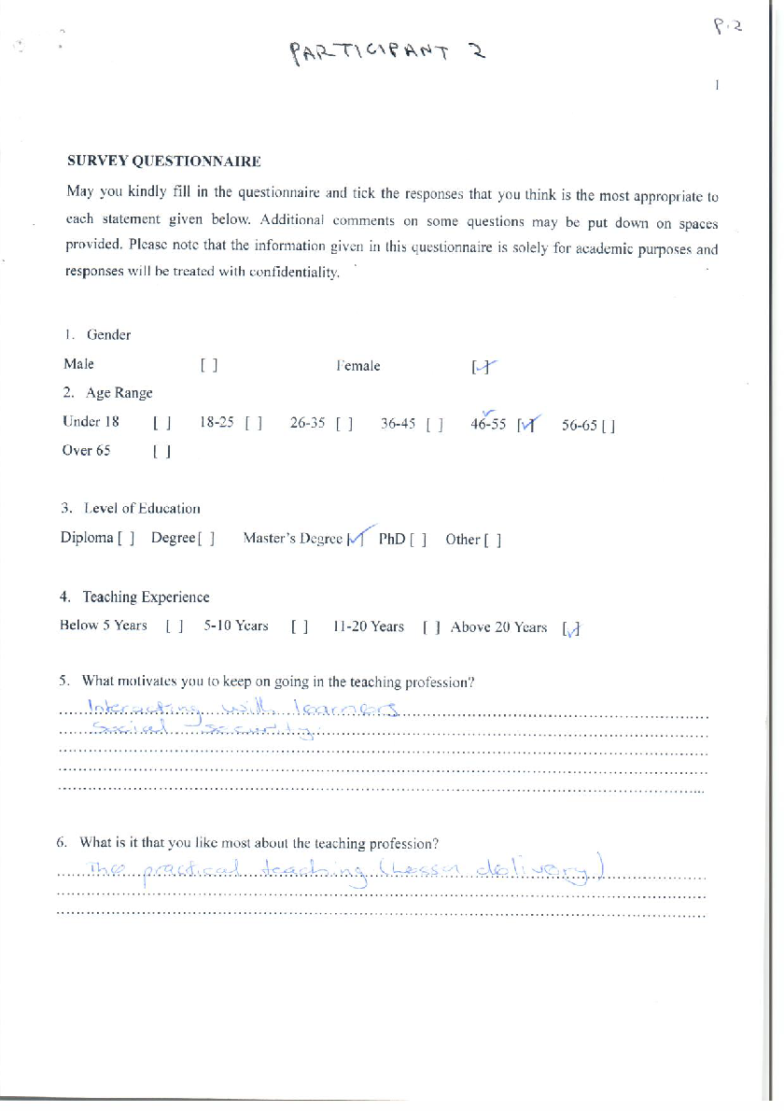






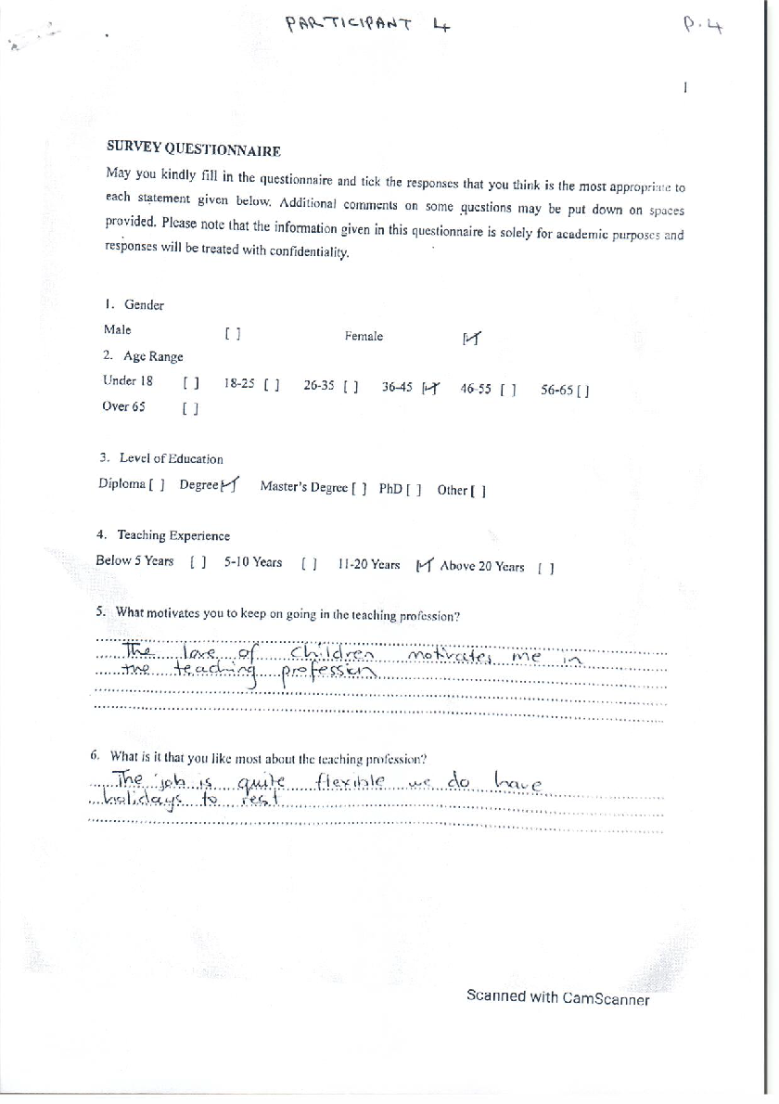


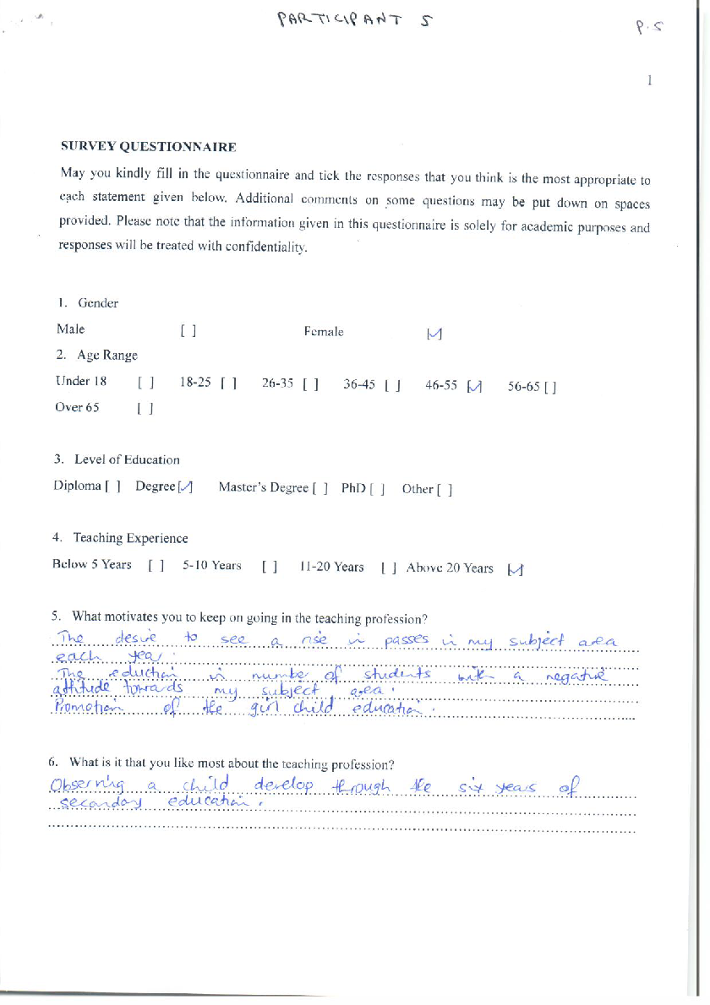





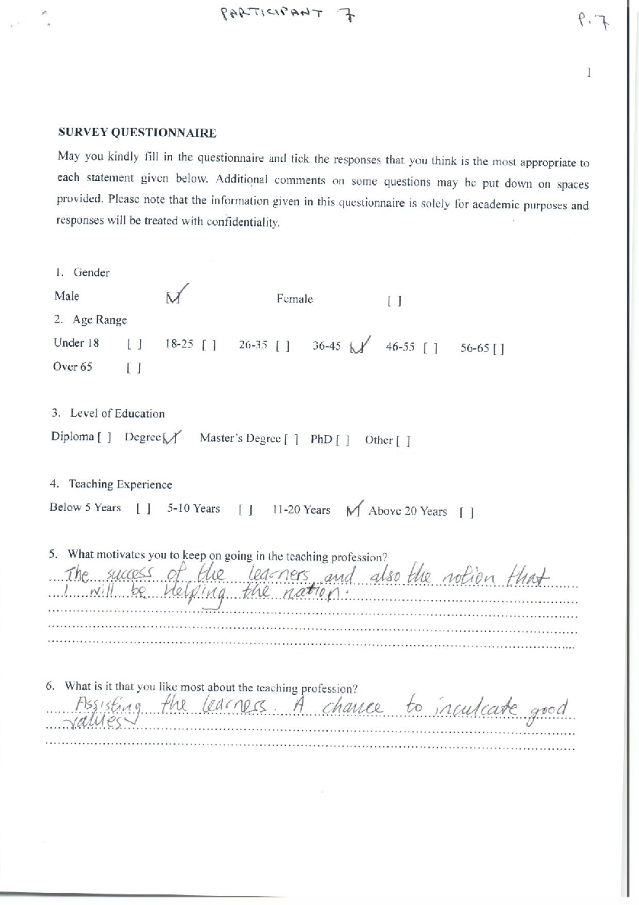





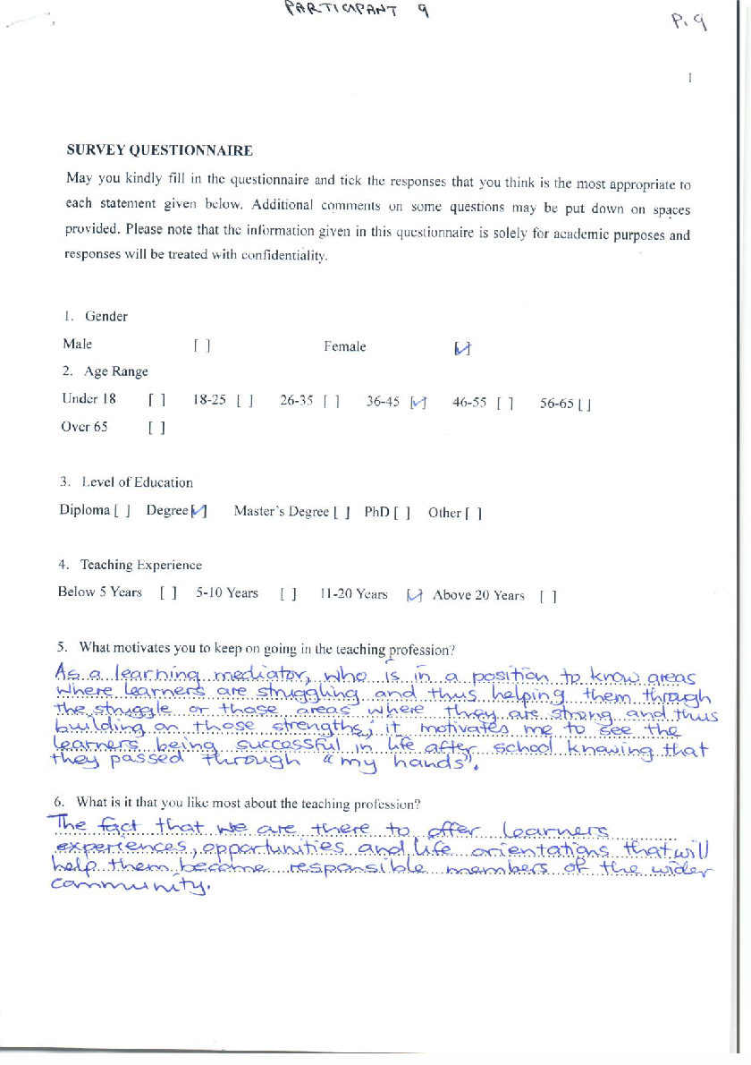



This dominion does not justify absolute dominion over other creatures, but it comes with responsibility. It is relational dominion (Laudato Si, 67). Dominion is co-creating and not destroying.
Work in this paper refers to human effort or labour for reasons other than pleasure.
A vocation is a call from God to serve. Hence, it is for all people and not only for the clergy and consecrated religious.
This school belongs to and is run by the Carmelite Friars in Zimbabwe.
The view of work as a job entails that one is concerned with just earning a living.
The view of work as a career refers to the understanding of work as merely for socio-psychological fulfilment.
I Have given page numbers to each paragraph which do not have pagination.
A vocation is a call from God to serve. Hence, it is for all people and not only for the clergy and consecrated religious.
The Church teaches that family life is a natural right to which human beings are called.
In this section, interviewees were responding to these three questions: 1) What is your understanding of a vocation and how would you describe your own vocation? 2) How would you describe the relationship between the work you do as a teacher and your vocation as a Christian? 3) Do you see your work as a teacher as contributing to the welfare of the less privileged?
Loco-parentis is the Latin term for, “in place of a parent” which refers to acting in a parental capacity. That is, assuming legal responsibility and some functions of a parent (Collins Dictionary.Com.).
According to Maslow’s understanding, physiological or lower needs are anthropologically viewed.
Thus, teachers empower learners to help one another.
These extra-lessons were done outside the school program aimed at charging an additional fee apart from the school fees paid.
According to the Statutory Instrument 1 of 2020, teachers should only conduct extra-lessons in the school and upon the Ministry approval (Muresherwa et al. 342).
The researcher is cognisant that extra work per se, must also receive extra remuneration. Nonetheless, work is not merely meant for financial benefit but also understood as God’s call to serve others, and in this case, to assist the less privileged students.
To highlight, teachers’ motivation entails a reason or reasons that keep them in the teaching field, and that which they love most pertains to their opinion of their work, whether or not they enjoy it or find it pleasant. Teachers might have good reasons to keep on teaching e.g., love of children, but they might not be enjoying teaching or finding it pleasant to teach. Therefore, ‘motivation’ and ‘like most’ are not so much divorced from each other but they are different.
In this section, interviewees were responding to the questions: 1) What are the factors that prevent teachers from approaching their work as a vocation? 2) What could be done to enable teachers to understand their work better and to deepen their sense of the vocational dimension of the work they do?
The combination of the economic hardships in the country and poor remuneration seem to erode the livelihood of the family. As a result, teachers fail to provide their families with proper and dignified clothing, shelter and food.
In this section, interviewees were responding to the question: In your view, how might the dignity of teachers and of the teaching profession be more effectively promoted?
From the nine teachers interviewed, seven of them are degree holders and the other two hold Masters’ Degrees. This serves to affirm that teachers in Zimbabwe’s level of education is high enough to be paid well.
This means that human beings do not just act as God’s partners, but in a particular sense create on behalf of God as created co-creators (Rheeder 7). Notably, the fact that human beings are created in the image of God serves as the foundation for this understanding of human beings as created co-creators.
I have given page numbers to each paragraph which do not have pagination.
The owners and runners of the school.
Following the principle of subsidiarity, the Church here, is properly represented by the Order of Carmelites.
While Lumen Gentium speaks of the difference between the laity and those in the holy orders and consecrated persons, it also states: “If therefore in the Church everyone does not proceed by the same path, nevertheless all are called to sanctity…” (LG 32), and “upon all the laity, therefore, rests the noble duty of working to extend the divine plan of salvation to all people of each epoch and in every land” (LG 33). As such, teachers and pastors’ work are both God’s calling, a vocation.
In this context, an oath is a solemn promise made before a witness. It is a legal commitment expressing the truth.
They have a slant on work-as-a-vocation as found in Laborem Exercens.

